Ch2 – A Snake Charmer’s Story
Answer the following questions
- They can make snakes dance by playing the been . They learn this art from their family members – What they are called ? MB
Write about their profession?
Answer – They are Kalbeliyas
Kalbeliyas are known as professional snake charmers, snake handlers, and collectors of snake venom, earning a living by catching and selling snakes, as well as by performing with them at gatherings. They are also skilled in extracting and selling snake venom .

Q2 . Observe the given diagram and name the part of snake marked in the diagram ! Write it’s function .
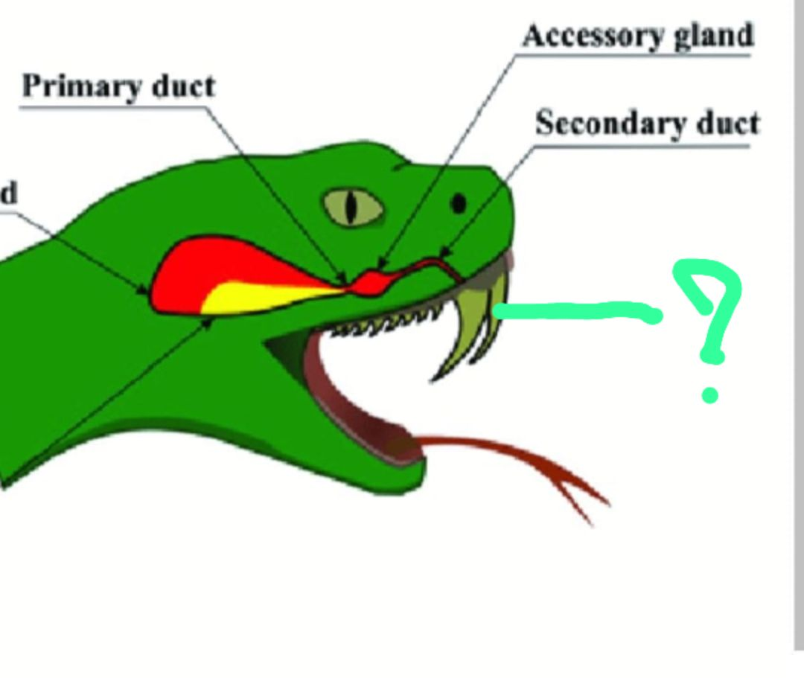

In snakes, fangs are specialized, modified teeth associated with a venom gland, used to inject venom into prey.

Q.3 The government has made a law that no one can catch and keep snakes . Do you support this step of government explain your answer .
Answer – I support this law . Even though many animals are made captive by killing their freedom ,no human has a right to hamper others for their livehood .
I completely support this law of not catching and keeping animals captive .

Q4. While coming back from school Raju got a snake bite on his leg . He was immediately admitted to hospital and doctors treated him by carefully observing the snake bite mark ! Do you know what is the treatment for snake bite ?

Ans – Yes , Snake bite is treated by antivemon , it helps neutralize the venom and is the best treatment for destroying the snake poison which is harmful for human body .

5. Write difference between poisonous and non poisonous snake ?

Answer by students .

